

**DATABASE REPORT**

WRITTEN FOR DATABASE COURSE FASILKOM UI INTERNATIONAL FALL 2015

AUTHORED BY ANDI RAHMAT, FARRAS A P, IRSYAD NABIL, RICKY ARKAN S UNDER SUPERVISION OF [NAMA PANJANGNYA PAK BEYE?] AS LECTURER

1. INTRODUCTION
   1. BACKGROUND

Gujek CEO Mr. Nadim had asked our team to develop simple application program that was intended to maintain the database system alongside the Gujek customer application. The mapping from IA-3 is used as the foundation for constructing the schema, tables and constraint in the RDBMS, The RDBMS used is PostGreSQL. The program also has given a few condition to fulfill the real world requirement.

The program is developed using Python language. The GUI also used as mediums for all functionalities.

* 1. OBJECTIVES

The program should be able to do following things below:

* Showing all tuples/rows of each table in the database
* Creating (inserting) a new tuple/row of each table in the database
* Editing (updating) existing tuple/row of each table in the database
* Deleting existing tuple/ row of each table in the database
* Print Existing tuple/row of each table in the database

1. HOW IT WORKS

The program is divided into 3 section:

1. The GuJek database that contains information about the company (employee, department, etc)
2. The Graphic User Interface (GUI) that the user can run and operates on
3. And the python program that connects the GUI with the database.

SQL Statements used in the program:

|  |  |  |
| --- | --- | --- |
| **No.** | **SQL Statements** | **Syntax** |
| 1. | INSERT INTO | INSERT INTO table_name (column1, column2, column3,...) VALUES (value1, value2, value3,....) |
| 2. | SELECT | SELECT column_name(s) FROM table_name |
| 3. | SELECT * | SELECT * FROM table_name |
| 4. | DELETE FROM | DELETE FROM table_name WHERE some_column=some_value |
| 5. | UPDATE | UPDATE table_name SET column1=value, column2=value,... WHERE some_column=some_value |
| 6. | AND/OR | SELECT column_name(s) FROM table_name WHERE condition AND/OR condition |
| 7. | ORDER BY | SELECT column_name(s) FROM table_name ORDER BY column_name [ASC |
| 8. | WHERE | SELECT column_name(s) FROM table_name WHERE column_name operator value |
| 9. | LIKE | SELECT column_name(s) WHERE column_name LIKE pattern |
| 10. | INNER JOIN | SELECT column_name(s) FROM table_name1 INNER JOIN table_name2 ON table_name1.column_name=table_name2.column_name |

Program features:

1. Viewing a table in the database: The program will show 'employee' table as its default. When a user selects a different table from the drop down menu, it will access the new table and shows it on the window. It uses the show_table in the python program which uses the SELECT * SQL statement.
2. Adding a record/entry to a table: The user will be prompted to fill the information needed for the table using the _setup_form method from the App class. The input will be put as a tuple and the program will use the insert method from the GujekAdmin class. This method will then prompt the INSERT INTO SQL statement.
3. Editing a record/entry: This method will edit a chosen data from the database, with tablename (str) for The table name, searchby (str) for The column name, value (str) for The data to be edited and data (str) for The new data for value.
4. Deleting a record/entry: This method will delete data from the database with tablename (str) for The table name, data (dict) for The data that specifies deletion condition.
5. Ordering a table by the chosen column:(??)
6. Searching a record/entry from a column in the table: This method will search the database for the given value and return its value with tablename (str) for The table name, searchby (str) for The column name and value (str) for The search key.
7. HOW TO USE THE APPLICATION

Before you run the program:

* Make sure you use PostgreSQL 9.4.
* Create a postgresql with user='gujekadmin' and password='admin1'.
  + Open psql and type in: CREATE USER gujekadmin WITH SUPERUSER password 'admin1';.

To start using the program:

1. Open Gujekadmin.py
2. 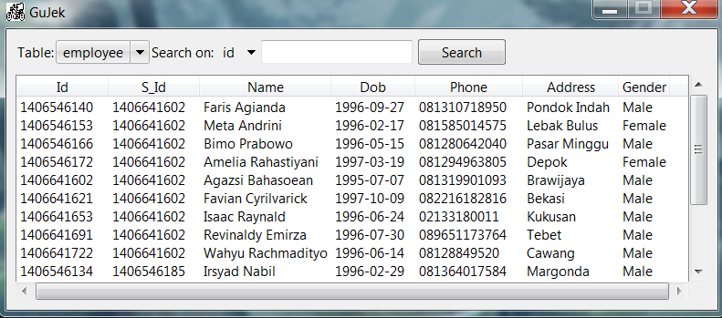This window will be opened:
3. **Show table**

To change the table shown, click the drop down menu beside the “table” and choose the table you want to see.

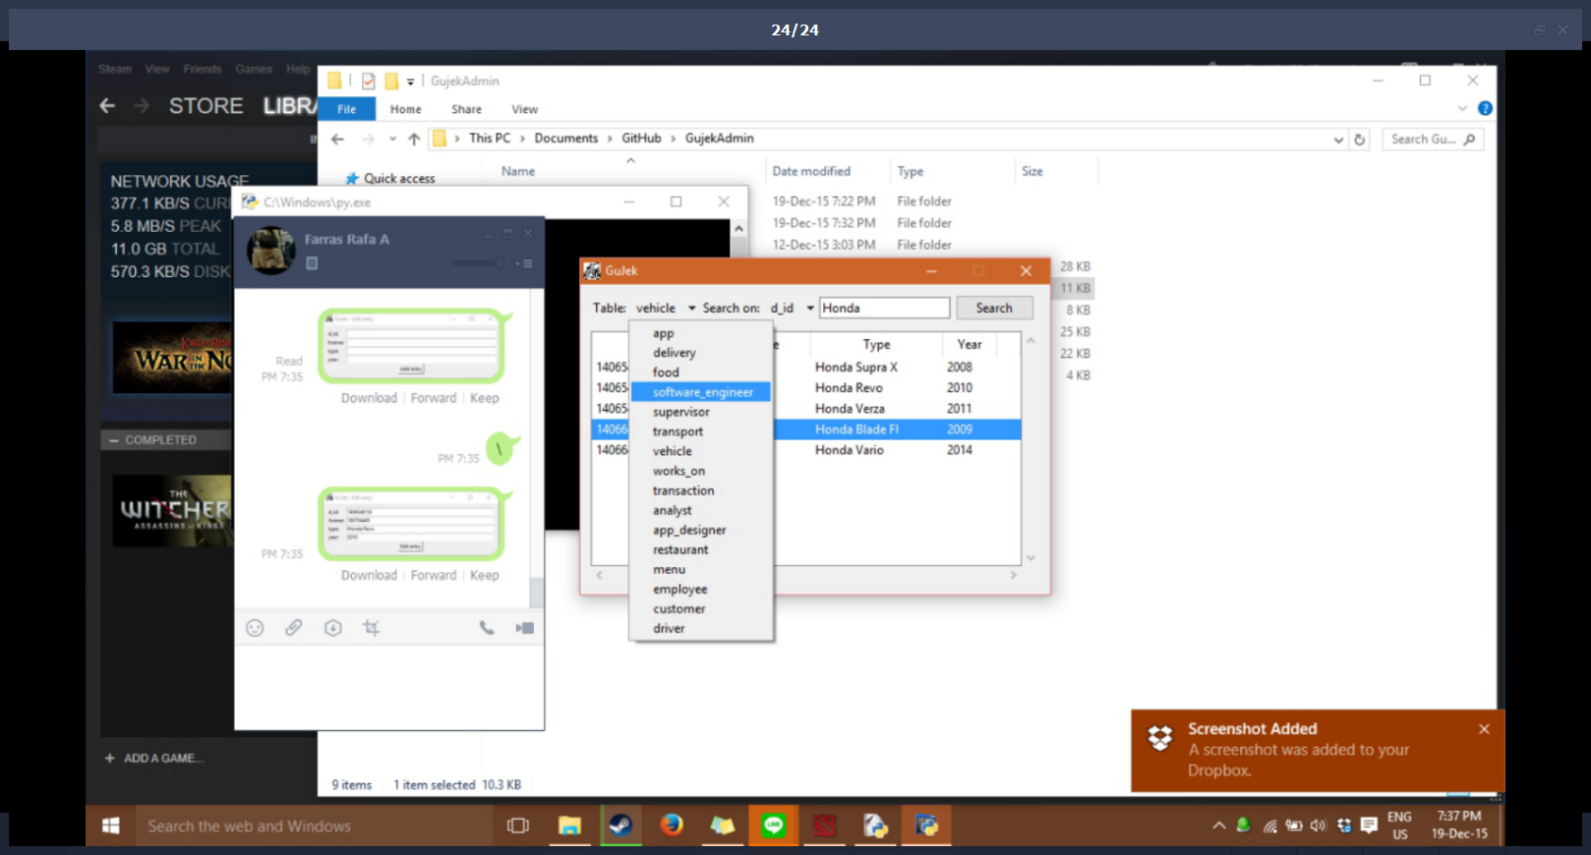

1. **Search**

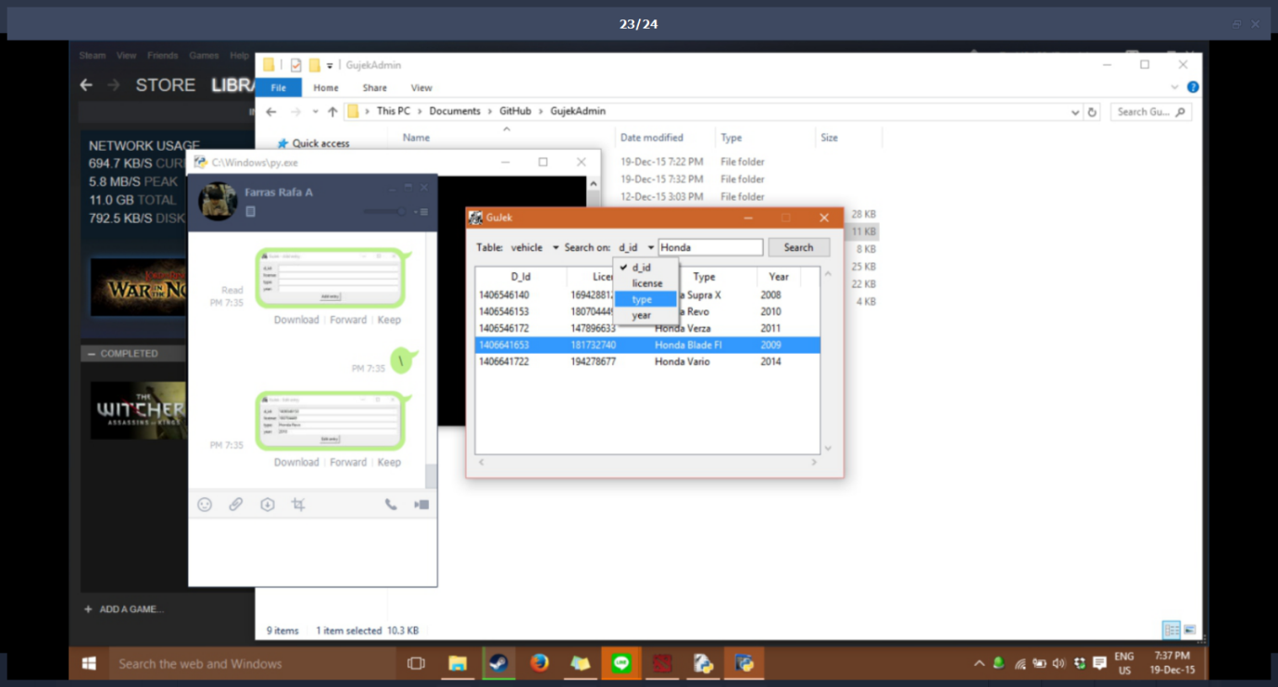To search certain word, click on the drop down beside “search on” and select the column you want to search the word on. Then, type the word (e.g honda) and hit the search button.

1. **Create new row**

* To Create (insert) a new tuple/row on a table, right click on one of the row and choose “add row”.

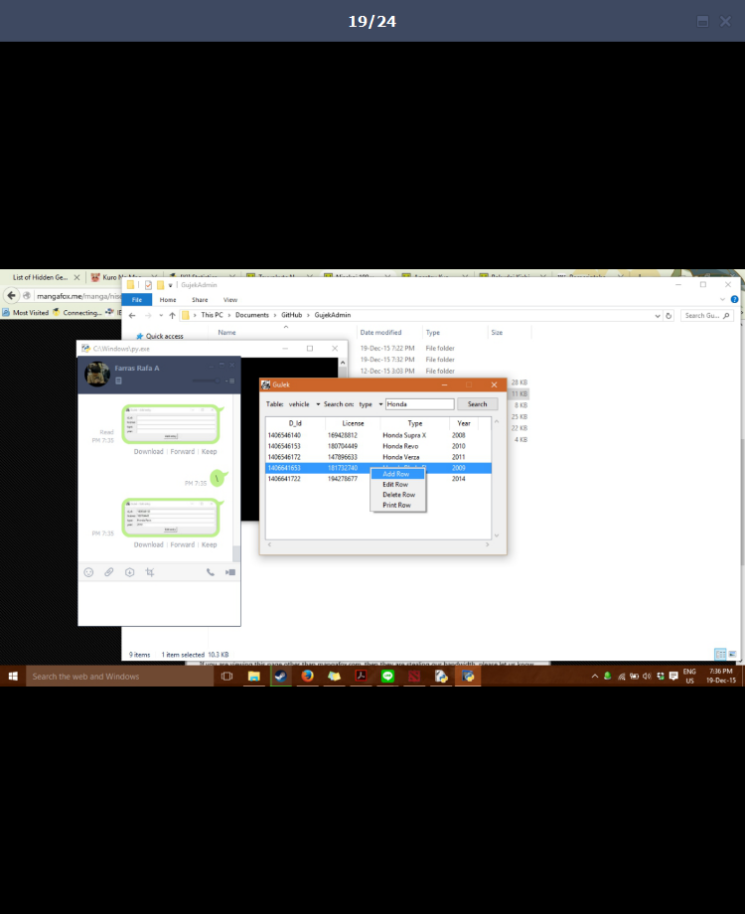

* This will open a new window where you can fill in the details of the row you want to add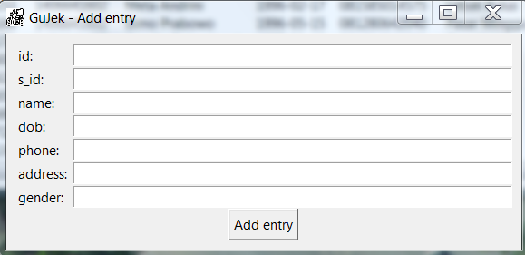

1. **Edit row**

* 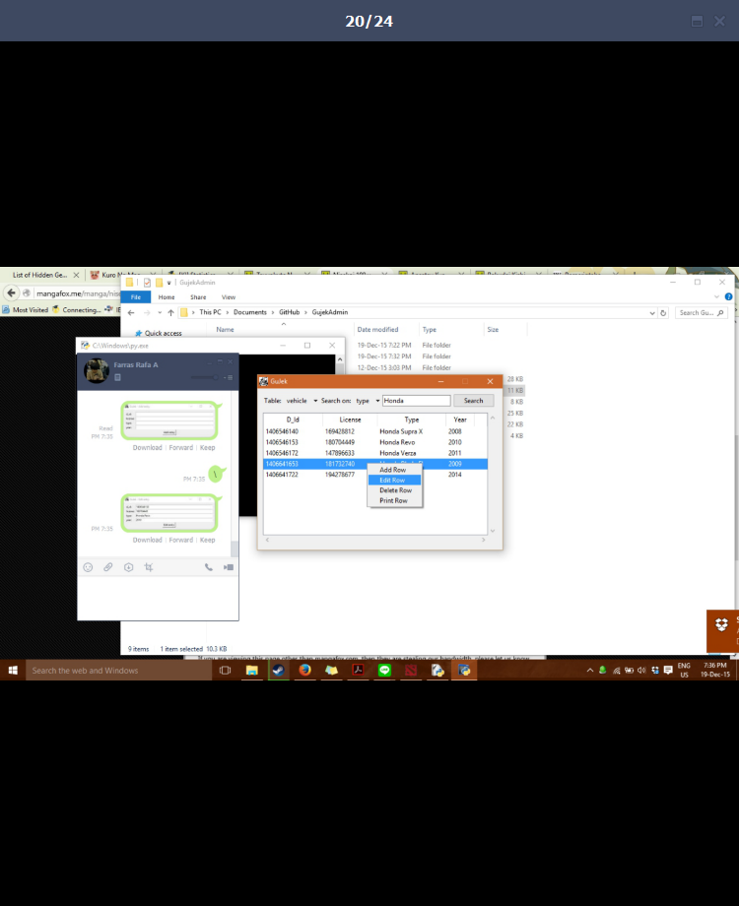To edit (update) an existing tuple/row on a table, right click on the row you wish to update and choose “add row”.
* This will open a new window where you can fill in the details of the row you want to update.

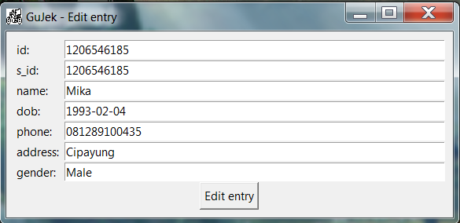

1. **Delete row**

* To delete a tuple/row on a table, right click on the row you wish to delete and choose “delete row”

.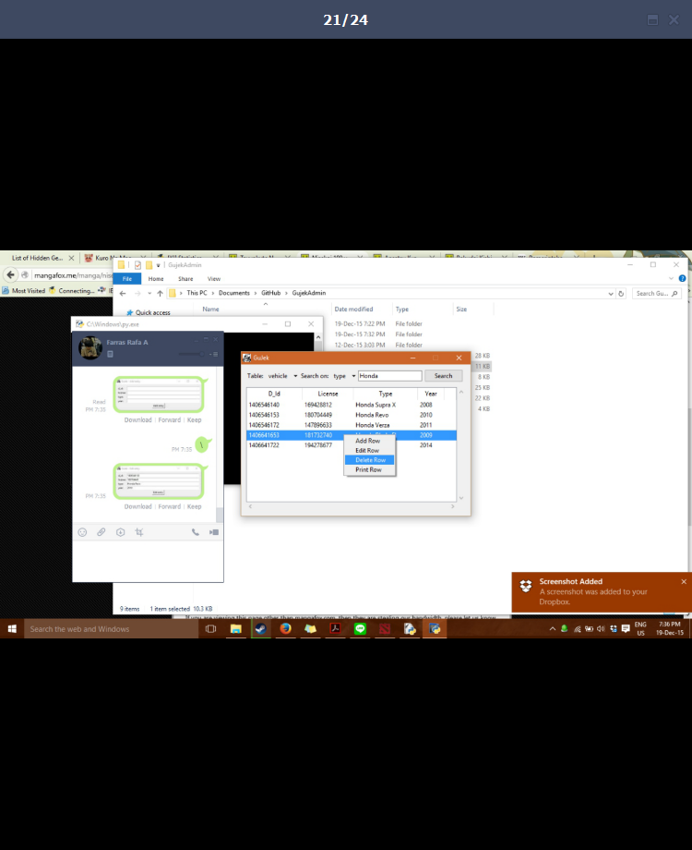

* Click “OK” to delete the table entry.

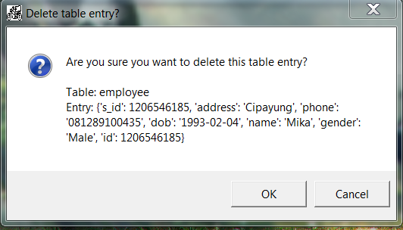

1. **Print row**

* To print a tuple/row from a table, right click on the row you wish to print and choose “print row”.

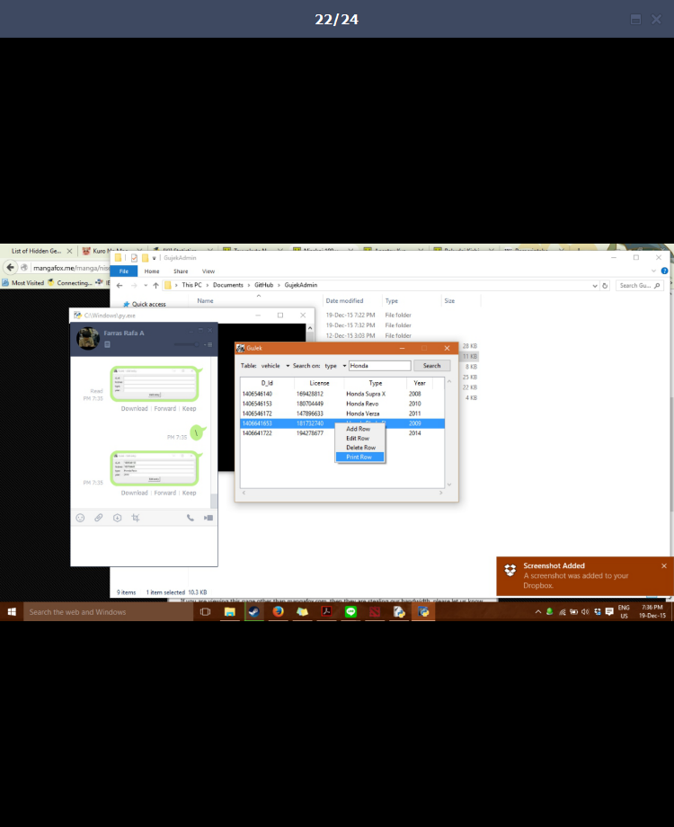

* The row should be printed just like in the picture below:

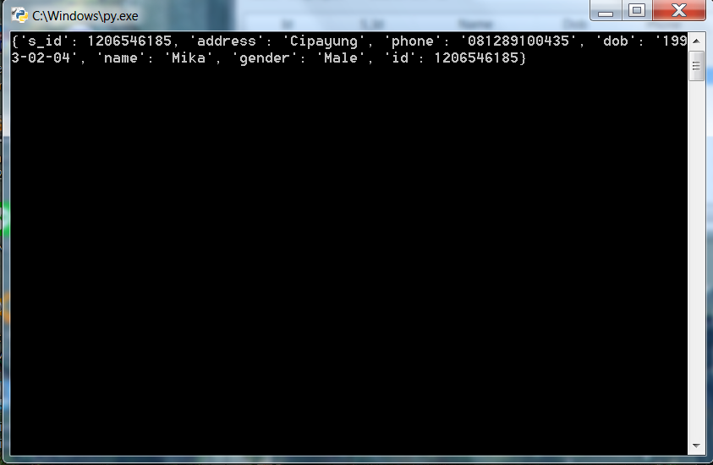

1. **Order the table in a descending/ascending manner [bener gak nih bagian ini]**

* Click on the header of the column you wish to order, once for ordering in descending manner, and twice for ordering in ascending manner.

1. JOB DESCRIPTIONS [spesifik apa gimana??]

* Andi Rahmat Ramadhan H : Programmer(?)
* Farras Apsari P : Project Manager(?)
* Irsyad Nabil : Programmer(?)
* Ricky Arkan S : Programmer(?)